**Low Level Design (LLD) of CRM**

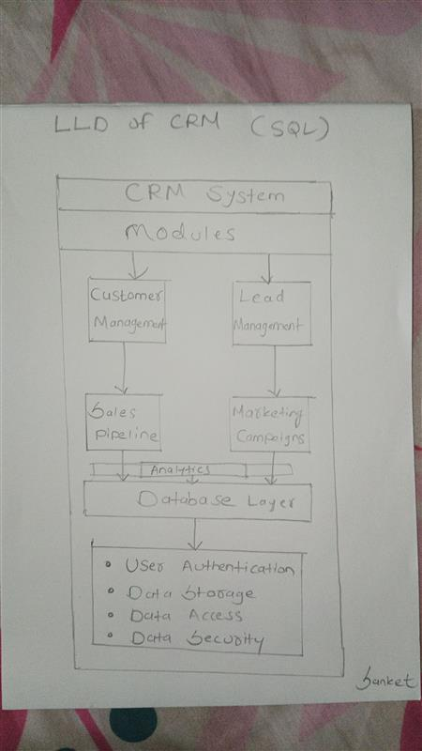

1. **User Management:**

**Description:** This module handles user authentication, authorization, and management within the CRM system.

**Features:**

* User registration and login functionality.
* Role-based access control (RBAC) to manage permissions.
* Secure password storage using hashing algorithms.
* Account management for user profile updates and password resets.

1. **Customer Data Management:**

**Description:** This module focuses on storing and managing customer information.

**Features:**

* Customer profile creation with fields for contact details, demographics, and preferences.
* Ability to track customer interactions, such as emails, calls, meetings, and purchases.
* Import/export functionality for bulk data operations.
* Data validation to ensure accuracy and consistency of customer information.

1. **Lead Management:**

**Description:** This module is responsible for capturing and qualifying leads.

**Features:**

* Lead capture forms on the website, social media channels, and other sources.
* Lead scoring mechanism to prioritize leads based on predefined criteria.
* Lead assignment to sales representatives based on territory or workload.
* Conversion of qualified leads into opportunities within the system.

1. **Opportunity Management:**

**Description**: This module tracks potential deals and their progression through the sales pipeline.

**Features:**

* Opportunity creation with details like deal size, expected close date, and probability of success.
* Pipeline visualization to view opportunities by stage and value.
* Automated reminders and notifications for follow-ups and next steps.
* Integration with quotation and proposal generation tools.

1. **Communication Management:**

**Description**: This module handles communication channels with customers.

**Features:**

* Email integration for sending and receiving messages within the CRM.
* Call logging and recording with notes and follow-up actions.
* Integration with SMS and chat platforms for real-time communication.
* Automated email campaigns and drip marketing.

1. **Task and Activity Management:**

**Description:** This module manages tasks and activities related to leads, opportunities, and **customer interactions.**

**Features:**

* Task creation, assignment, and tracking with due dates and priorities.
* Activity logging for meetings, demos, and other interactions.
* Calendar integration for scheduling appointments and reminders.
* Collaboration features for team members to share notes and updates.

1. **Reporting and Analytics:**

**Description**: This module provides insights into sales performance and customer behavior.

**Features:**

* Predefined reports for sales metrics, lead conversion rates, and pipeline analysis.
* Custom report builder for ad-hoc queries and analysis.
* Visualization tools like charts and graphs for data presentation.
* Integration with business intelligence (BI) platforms for advanced analytics.

1. **Integration**:

**Description**: This module facilitates integration with external systems and services.

**Features**:

* APIs for seamless integration with ERP, accounting, marketing, and support systems.
* Webhooks for real-time data synchronization with third-party applications.
* Data mapping and transformation to ensure compatibility between systems.
* Error handling and logging for monitoring integration processes.

1. **Security and Compliance:**

**Description**: This module ensures the security and compliance of the CRM system.

**Features:**

* Role-based access control (RBAC) with granular permissions.
* Data encryption in transit and at rest to protect sensitive information.
* Audit trails and logging for tracking user activities and changes.
* Compliance with regulations such as GDPR, CCPA, and HIPAA.

1. **Scalability and Performance:**

**Description**: This module addresses the scalability and performance of the CRM system.

**Features:**

* Horizontal scalability through load balancing and clustering.
* Performance tuning with database indexing, query optimization, and caching.
* Monitoring tools for tracking system health, resource usage, and performance metrics.
* Capacity planning to anticipate and accommodate future growth in data and user traffic.

**Conclusion-** This detailed low-level design outlines the various components, modules, and features of a CRM system, providing a comprehensive framework for implementation. Each module can be further refined and implemented according to specific business requirements and technical considerations.